**Week 12:**

Create an application to implement Animated Text in Flutter.

**Animated Text in Flutter**

Animations make the UI more interactive and enhance the user experience. There is no limitation of creativity when it comes to animations or making the application more interactive. In Flutter, we got an easy way to display Animated text. In this article, we will see how we can animate texts using animated_text_kit.

### ****Types of Text Animations:****

Following are the types of text animations available with the animated_text_kit package:

1. RotatedAnimatedText()
2. ScaleAnimatedText()
3. FadeAnimatedText()
4. TyperAnimatedText()
5. WavyAnimatedText()
6. FlickerAnimatedText()

We can also create customized animated texts. Let us move to the implementation part of this package.

### ****Install the package:****

Add animated_text_kit package to the *pubspec.yaml*file:

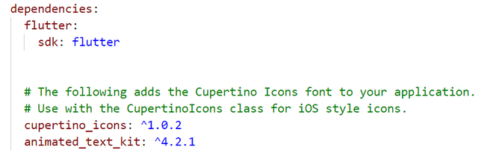

Then configure it using pub get. You can also install the package from the command line by running the following command:

flutter pub add animated_text_kit

### ****Implementation:****

We use AnimatedTextKit() widget to create animated texts. In the *animatedTexts* property, we can add as many texts and any type of animated texts like RotatedAnimatedText, FlickerAnimatedText, etc.

Some properties of AnimatedTextKit are –

* animatedTexts
* onTap
* totalRepeatCount
* repeatForever
* pause
* displayFullTextOnTap
* isRepeatingAnimation

import 'package:flutter/cupertino.dart';

import 'package:flutter/material.dart';

import 'package:animated_text_kit/animated_text_kit.dart';

void main() => runApp(MyApp());

class MyApp extends StatefulWidget

{

@override

_MyAppState createState() => _MyAppState();

}

class _MyAppState extends State<MyApp>

{

@override

Widget build(BuildContext context)

{

return MaterialApp(

title: 'Animated Text Kit',

debugShowCheckedModeBanner: false,

theme: ThemeData(primarySwatch: Colors.green),

home: Scaffold(

appBar: AppBar(

title: const Text("Welcome to Animated Text Demo"),

centerTitle: true,

),

body: Column(

mainAxisAlignment: MainAxisAlignment.center,

children: <Widget>[

AnimatedTextKit(

animatedTexts: [

RotateAnimatedText('Welcome to VJIT',

textStyle: TextStyle(

fontSize: 30,

color: Colors.white,

backgroundColor: Colors.blue)),

RotateAnimatedText('Dept. of CSE-DS',

textStyle: TextStyle(

letterSpacing: 3,

fontSize: 30,

fontWeight: FontWeight.bold,

color: Colors.orange)),

RotateAnimatedText(

'Hyderabad',

textStyle: TextStyle(

fontSize: 30,

decoration: TextDecoration.underline,

),

),

],

isRepeatingAnimation: true,

totalRepeatCount: 10,

pause: Duration(milliseconds: 1000),

),

// SizedBox(height: 10),

Center(

child: AnimatedTextKit(

totalRepeatCount: 40,

animatedTexts: [

FadeAnimatedText(

'First Fade',

textStyle: const TextStyle(

backgroundColor: Colors.green,

color: Colors.white,

fontSize: 32.0,

fontWeight: FontWeight.bold),

),

ScaleAnimatedText(

'Then Get Bigger',

duration: Duration(milliseconds: 4000),

textStyle:

const TextStyle(color: Colors.indigo, fontSize: 50.0),

),

],

),

),

SizedBox(height: 10),

AnimatedTextKit(

animatedTexts: [

TyperAnimatedText('This is Animated text,',

textStyle: const TextStyle(

color: Colors.white,

fontSize: 30,

backgroundColor: Colors.purple)),

TyperAnimatedText('You are viewing it here.',

textStyle: const TextStyle(

fontSize: 20, fontWeight: FontWeight.bold)),

],

onTap: () {

print("I am executing");

},

),

SizedBox(height: 10),

Center(

child: AnimatedTextKit(

animatedTexts: [

WavyAnimatedText('Hello World',

textStyle: TextStyle(

color: Colors.blue,

fontSize: 30,

)),

WavyAnimatedText('Look at the waves',

textStyle: TextStyle(

color: Colors.green[600],

fontSize: 30,

)),

],

repeatForever: true,

onTap: () {

print("Tap Event");

},

),

),

],

),

));

}

}

**OUTPUT**

